
JURNAL TEKNIK INFORMATIKA
Homepage : http://journal.uinjkt.ac.id/index.php/ti

COMPARATIVE STUDY OF LSTM, XGBOOST, AND HYBRID MODELS FOR BITCOIN PRICE FORECASTING

Sapar_Hidayat._S1¹, Novrizal_Fattah_Fahmitra_2², Tekad_Matulatan_3³

^{1,2,3}Informatics Engineering Study Program, Faculty of Engineering and Maritime Technology
^{1,2,3}Universitas Maritim Raja Ali Haji
^{1,2,3}Tanjungpinang, Kepulauan Riau, Indonesia
E-mail: ¹2201020003@student.umrah.ac.id, ²xxx@university.ac.id, ³xxx@university.ac.id

 | ABSTRACT  Bitcoin price prediction remains a complex challenge in financial analysis due to the highly volatile and non-linear nature of cryptocurrency markets. This study evaluates and compares the predictive performance of a standalone Long Short-Term Memory (LSTM) network, an eXtreme Gradient Boosting (XGBoost) algorithm, and a sequential Hybrid LSTM-XGBoost stacking framework. Utilizing historical Bitcoin to Indonesian Rupiah (BTC/IDR) daily data, the models were trained to forecast future closing prices using Open and Close features within a 30-day sliding window. To avoid recursive error accumulation, a Direct Multi-Step (DMS) forecasting strategy was implemented across 1-day, 3-day, and 7-day horizons. The models were evaluated on chronological out-of-sample testing data using Root Mean Squared Error (RMSE), Mean Absolute Error (MAE), and Mean Absolute Percentage Error (MAPE). Experimental results demonstrate that predictive superiority is horizon-dependent. The standalone LSTM achieved the lowest error rates for the immediate 1-day horizon. However, the Hybrid LSTM-XGBoost model comprehensively outperformed standalone architectures at the 3-day horizon. For the 7-day horizon, the Hybrid model maintained the lowest RMSE, whereas the LSTM retained the best MAE and MAPE. These findings indicate that model selection should be dynamically tailored to the intended prediction horizon for optimal decision-support.  Keywords: Bitcoin, Deep Learning, Direct Multi-Step Forecasting, Hybrid Stacking, LSTM, XGBoost
  Article:  Accepted: xxx xx, 20xx  Revised: xxx xx, 20xx  Issued: xxx xx, 20xx  *Correspondence Address:  (email) | ABSTRACT  Abstract is a synopsis of the work containing the problems studied, the purpose of research, information and methods used to solve problems, and conclusions. Articles must be submitted in print-ready format and are limited to a minimum of ten (10) pages and a maximum of twelve (12) pages. Abstract is a synopsis of the work that contains the issues studied, the research purpose, the information and methods used to solve the problem, and the research conclusion. Abstracts are limited to 200 words and should not contain references, mathematic equations, figures, and tables. The font size for abstracts, keywords, and body of article is 11pt. Keywords are no more than six (6) words, but the minimum is three (3) words.  Keywords: Web, Asset Management, CodeIgniter, Bootstrap

- INTRODUCTION

The rapid development of digital financial assets has significantly transformed the global financial ecosystem, with cryptocurrencies emerging as a highly disruptive innovation in modern finance [1]. Among various digital assets, Bitcoin remains the most dominant and widely adopted cryptocurrency, serving not only as a medium of exchange but also as a speculative investment instrument and a store of value [2]. However, Bitcoin operates in a highly decentralized and sensitive market environment, making its price mechanisms inherently susceptible to macroeconomic indicators, regulatory shifts, and volatile investor sentiments [3], [1]. Consequently, the market behavior of Bitcoin is characterized by extreme price volatility and chaotic fluctuations, where its valuation can change drastically within very short periods [4], [5].
This inherent volatility and the complex, non-linear patterns of Bitcoin's price movements render accurate forecasting an exceptionally complex challenge [6]. Traditional statistical forecasting methods, such as Autoregressive Integrated Moving Average (ARIMA) and Generalized Autoregressive Conditional Heteroskedasticity (GARCH), rely heavily on strict stationary assumptions and linear mathematical relationships [7], [8]. While these classical models provide foundational insights into financial trends, they frequently fail to capture the sudden structural breaks, dynamic temporal dependencies, and noisy characteristics of cryptocurrency time series, thereby leading to suboptimal predictive performance in highly volatile environments [2], [6].
Despite these intricacies, developing robust and reliable forecasting models for Bitcoin is of paramount importance [9]. Accurate price predictions are essential for supporting market analysis, enabling institutional and individual investors to support their investment analysis, and facilitating effective decision-support systems for financial risk management against sudden market downturns [10], [4]. Furthermore, the continuous improvement of forecasting methodologies contributes significantly to the scientific understanding of digital market microstructures and the broader advancement of computational intelligence methods applied to financial technology [7], [11]. The inability of linear econometric models to adapt to sudden market shifts underscores the critical need for more advanced, data-driven analytical approaches to navigate the uncertainties of digital asset markets [5].
To overcome the limitations of traditional econometrics, recent time-series forecasting research has heavily shifted towards machine learning and deep learning methodologies [12]. Among these advanced architectures, the Long Short-Term Memory (LSTM) network has proven highly effective in processing sequential financial data [13]. LSTM networks address the vanishing gradient problem found in standard recurrent neural networks by employing specialized input, forget, and output gates [12], [2]. This capability allows LSTM to selectively retain essential historical information over extended periods, making it highly proficient at capturing the long-term temporal dependencies and complex non-linear patterns of Bitcoin price movements [4], [9].
In parallel, ensemble machine learning methods, particularly Extreme Gradient Boosting (XGBoost), have demonstrated outstanding predictive capabilities [14]. XGBoost operates by iteratively combining multiple weak decision trees and minimizing residual errors through a gradient boosting framework, offering high computational speed and incorporating regularization mechanisms to help mitigate overfitting [9]. Its ability to efficiently model complex, non-linear relationships within feature spaces has made it a formidable tool for financial predictions, often outperforming deeper architectures in scenarios requiring rapid adaptation to sudden outliers or anomalies [10], [15].
A critical synthesis of existing literature reveals varied approaches and conflicting outcomes regarding the superiority of these algorithms. Several studies focusing exclusively on LSTM emphasize its excellent sequence learning but note its tendency to produce lagging predictions during abrupt market shocks or sudden price discovery phases [2], [5]. Conversely, research evaluating standalone XGBoost highlights its efficiency and accuracy but points out its limited capacity to inherently model long-term sequential continuity over extended periods [14]. To leverage the strengths of both paradigms, researchers have begun exploring hybrid and ensemble models [7]. Various integrations, such as combining convolutional networks with LSTM [16], [17], stacking LSTM with Random Forest [5], and merging LSTM with XGBoost [15], have been proposed to investigate whether residual correction can enhance prediction stability across non-stationary time series [11]. Furthermore, several existing studies rely on standard recursive forecasting, which is prone to error accumulation over time, rather than evaluating models using a Direct Multi-Step (DMS) forecasting strategy to assess each horizon directly and avoid error propagation [18]. Lastly, a significant portion of the literature focuses heavily on the Bitcoin to United States Dollar (BTC/USD) pairing, leaving the dynamics of Bitcoin priced against emerging local fiat currencies, such as the Indonesian Rupiah (BTC/IDR), relatively limited in exploration [2].
This study addresses these gaps by establishing a highly controlled and standardized evaluation framework for cryptocurrency prediction. The primary scientific contribution of this research lies in the rigorous, direct comparative analysis of a standalone LSTM, a standalone XGBoost, and a sequential Hybrid LSTM-XGBoost stacking model under strictly identical experimental conditions. All models are trained and evaluated using a consistent dataset encompassing the Open and Close prices of the BTC/IDR trading pair from January 1, 2020, to May 20, 2026. To provide a consistent basis for comparison, identical preprocessing pipelines are applied across all models. This encompasses currency format cleaning, chronological sorting, forward filling for missing values, sliding window extraction with a 30-day size using Open and Close prices as input features, and Min-Max Normalization fitted exclusively on the training data to reduce the risk of data leakage [14], [2]. The dataset is strictly partitioned into a training period (January 1, 2020, to December 31, 2025) and an out-of-sample testing period (January 1, 2026, to May 20, 2026). Moreover, this research implements a Direct Multi-Step Forecasting strategy targeting 1-day, 3-day, and 7-day future horizons, evaluated entirely through out-of-sample testing using Root Mean Squared Error (RMSE), Mean Absolute Error (MAE), and Mean Absolute Percentage Error (MAPE) to ensure realistic performance measurement [18], [9].
The primary objective of this research is to analyze and compare the performance of LSTM, XGBoost, and Hybrid LSTM–XGBoost models in predicting future Bitcoin closing prices across multiple forecasting horizons, specifically 1, 3, and 7 days ahead. This comparative evaluation aims to identify the performance characteristics and limitations of each model based on RMSE, MAE, and MAPE metrics within different temporal scopes. This article is the original result of research and development conducted based on the authors' own ideas and technical implementations.

- METHODOLOGY

- Research Framework
The research framework is designed to provide a consistent and systematic evaluation framework for assessing cryptocurrency price forecasting models [13]. The methodology encompasses several sequential stages, beginning with the collection of historical Bitcoin price data. The collected data undergoes a data cleaning and preprocessing phase to address formatting inconsistencies and missing values [2]. Subsequently, the dataset is transformed into a structured format through feature scaling and sliding window mechanisms to prepare the input sequences. The preprocessed data is partitioned chronologically into training and testing sets to preserve the temporal integrity required for time-series forecasting [7]. Following data preparation, the modeling phase involves the independent development of the Long Short-Term Memory (LSTM) network, the Extreme Gradient Boosting (XGBoost) algorithm, and the proposed Hybrid LSTM-XGBoost stacking architecture [15]. Hyperparameter tuning is integrated into the training pipeline to optimize model configurations [10]. A Direct Multi-Step (DMS) forecasting strategy is utilized to project future prices across 1-day, 3-day, and 7-day horizons [18]. Finally, the models are evaluated using out-of-sample testing data through standardized regression error metrics [6].

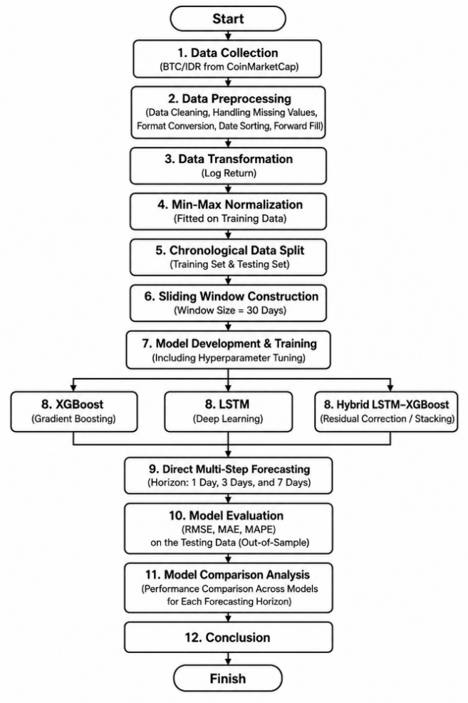
Figure 1. Research Workflow of the Proposed Study

- Dataset and Research Variables
This study utilizes historical time-series data of Bitcoin priced against the Indonesian Rupiah (BTC/IDR), providing a specific contextual analysis of cryptocurrency dynamics within emerging local fiat markets [1]. The dataset is sourced from CoinMarketCap and encompasses daily trading records over a period from January 1, 2020, to May 20, 2026. This timeframe captures multiple market cycles, including bullish trends, corrections, and periods of high volatility [3], [9]. The primary variables utilized for the forecasting models are the Open Price and Close Price. Historical closing prices are considered a critical indicator of market consensus at the end of a daily observation, making it the primary target variable for the predictive models [4]. The inclusion of the Open price serves as an additional contextual feature to assist the models in recognizing intra-day price movement patterns.

Table 1. Dataset Characteristics
Variable | Data Type | Description | Role in Model
Date (Tanggal) | Datetime | Represents the daily observation date of the BTC/IDR historical price data. The dataset is organized chronologically from January 1, 2020, to May 20, 2026. | Temporal Index
Open Price (Buka*) | Numeric (IDR) | Represents the Bitcoin price in Indonesian Rupiah at the beginning of each daily trading period. | Input Feature
Close Price (Tutup**) | Numeric (IDR) | Represents the Bitcoin price in Indonesian Rupiah at the end of each daily trading period. This variable reflects the final daily market value and is used as the primary basis for forecasting. | Input Feature and Target Variable

- Data Preprocessing
Data preprocessing is a vital step in financial time-series analysis to reduce noise and format inconsistencies that can degrade model learning [2]. The preprocessing pipeline begins with parsing the date column and sorting the entire dataset chronologically to strictly maintain the temporal order [7]. Next, the raw currency format is cleaned by stripping non-numeric characters, such as the "Rp" symbol and comma separators, allowing the Open and Close features to be converted into continuous floating-point numeric data. Missing values, which occasionally occur due to recording anomalies, are addressed using a forward-fill method. Forward filling replaces missing observations with the most recent available valid data point, effectively maintaining the continuity of the time series without introducing look-ahead bias [14].
Following data cleaning, the variables undergo normalization to stabilize the gradient descent optimization during neural network training [13]. The Min-Max scaling technique is applied to transform the features into a bounded range between 0 and 1. The normalization formula is defined as:
$$X_{norm}=\frac{X-X_{min}}{X_{max}-X_{min}}$$ | (1)
To reduce the risk of data leakage—where future information inappropriately influences the training process—the Min-Max scaler is fitted exclusively on the training dataset [14]. The calculated minimum and maximum bounds from the training phase are subsequently applied to transform the testing dataset, ensuring that the evaluation strictly reflects out-of-sample performance [11].

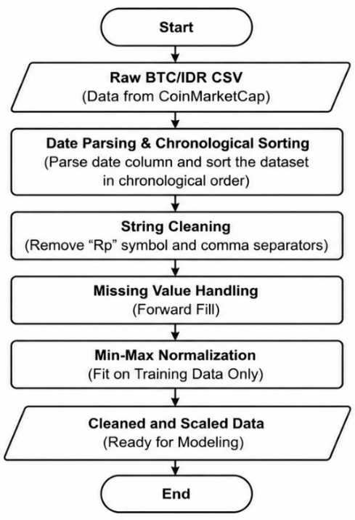
Figure 2. Data Preprocessing Pipeline

- Data Splitting and Sequence Construction
In time-series forecasting, standard random splitting techniques violate the temporal continuity of the data. Therefore, this study strictly employs a chronological data splitting strategy. The dataset is partitioned into a training set spanning from January 1, 2020, to December 31, 2025, and an out-of-sample testing set covering the period from January 1, 2026, to May 20, 2026. This out-of-sample approach ensures that the models are evaluated on unseen future data to assess their predictive reliability [5].
To format the data for the supervised learning algorithms, the continuous time series is restructured into input-output pairs using a sliding window technique. The sliding window size is set to 30 days, serving as the historical lookback period [2]. This mechanism extracts a sequence of 30 historical daily observations (both Open and Close prices) to form the feature matrix used to predict the future target Close price at a specific forecasting horizon. The relationship establishes that the historical sequence from time $t-29$ to time $t$ is utilized to predict the value at time $t+h$, where $h$ represents the target horizon of 1, 3, or 7 days [16]. For the testing sequences, the sliding window incorporates the tail end of the training data as historical context to predict the initial days of the testing period.

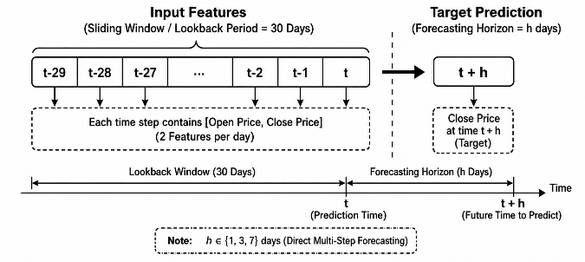
Figure 3. Sliding Window Construction with a 30-Day Lookback Period

- LSTM Model
The Long Short-Term Memory (LSTM) network is employed as the primary deep learning architecture due to its capability to extract complex temporal patterns and mitigate the vanishing gradient problem prevalent in traditional recurrent networks [9], [12]. The implemented LSTM architecture consists of a sequential structure designed to process the 30-day multivariate input matrices (Open and Close prices).
The model is initiated with a primary LSTM layer containing 50 computational units configured to return the full sequence output, enabling deeper feature extraction. A dropout layer with a rate of 0.2 is applied immediately after to randomly deactivate neurons during training, providing regularization to help mitigate overfitting [14]. This is followed by a secondary LSTM layer, also comprising 50 units, which outputs the final hidden state representation of the sequence, followed by another 0.2 dropout layer. The network concludes with a fully connected Dense layer of 25 neurons and a final Dense output layer containing a single neuron to produce the continuous price prediction [17].
The model utilizes the Adam optimizer with a Mean Squared Error (MSE) loss function. Training is conducted with a batch size of 32 for up to 50 epochs. To prevent overfitting and ensure optimal generalization, an early stopping mechanism is implemented with a patience of 5 epochs. This mechanism monitors the validation loss derived from a 10% validation split of the training data, ensuring the restoration of the best model weights once training ceases [10]. A fixed random seed (42) is utilized across all computational steps to support experimental reproducibility.

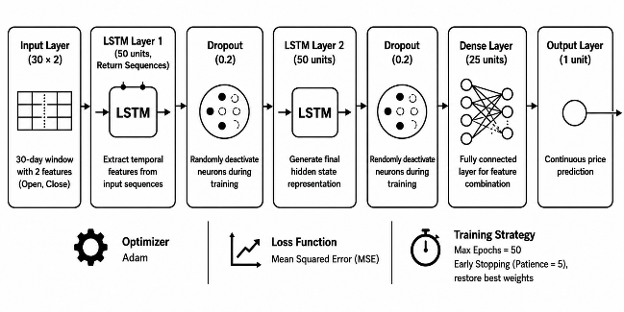
Figure 4. LSTM Architecture Used for Bitcoin Price Prediction

- XGBoost Model and Hyperparameter Optimization
The eXtreme Gradient Boosting (XGBoost) model serves as the primary machine learning baseline due to its high computational efficiency and capacity to map non-linear relationships within feature spaces [14]. Since XGBoost fundamentally expects two-dimensional tabular data rather than three-dimensional time-series sequences, the input sliding windows are flattened. Consequently, a 30-day window with 2 features is reshaped into a single vector of 60 features per sample [5].
To optimize predictive performance, a hyperparameter tuning process is executed using Randomized Search Cross-Validation (RandomizedSearchCV). Within the experimental setup, the search is configured with a 3-fold cross-validation (cv=3) evaluated through the negative mean absolute error metric [10]. The hyperparameter search space includes variations in the number of gradient boosted trees (n_estimators), learning rate (learning_rate), maximum tree depth (max_depth), and the subsampling ratios of the training instances (subsample) and columns (colsample_bytree) [14].

Table 2. XGBoost Hyperparameter Search Space
Hyperparameter | Search Space Values
n_estimators | {100, 200, 300}
learning_rate | {0.01, 0.05, 0.10}
max_depth | {3, 5, 7}
subsample | {0.7, 0.8, 0.9, 1.0}
colsample_bytree | {0.7, 0.8, 0.9, 1.0}

- Hybrid LSTM–XGBoost Model
To investigate whether integrating sequential learning with gradient-boosted trees can improve performance, a sequential Hybrid LSTM-XGBoost stacking architecture is proposed [15]. This hybrid approach employs a residual-correction mechanism designed to iteratively refine predictions [5], [11]. The methodology begins by training the LSTM network (using the aforementioned configuration of 30 epochs and an early stopping patience of 3) as the base learner on the sliding window sequences to map the primary temporal dependencies [16]. Once trained, the LSTM generates initial predictions in-sample on the training set. The residual error is then calculated by subtracting these in-sample LSTM predictions from the actual target values.
In the second stage, XGBoost acts as the meta-learner, tasked with modeling these residual errors rather than the raw target price. The flattened 2D historical features are used as the input for the XGBoost algorithm, which is trained to predict the structural deviations that the LSTM failed to capture [5]. The XGBoost meta-learner undergoes the same RandomizedSearchCV optimization process previously described. During the inference phase on the testing dataset, the final hybrid prediction is formulated by summing the primary forecast produced by the LSTM and the corrective residual adjustment predicted by the XGBoost meta-learner [11].

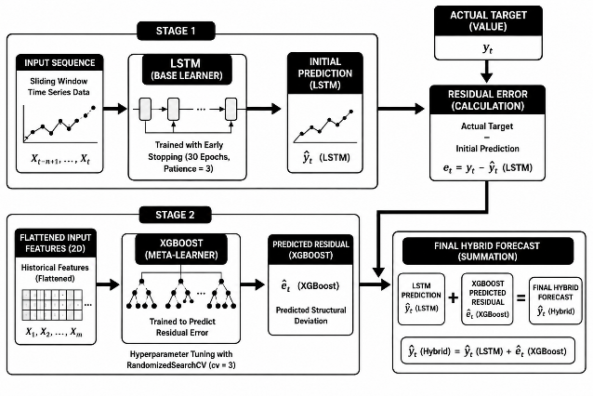
Figure 5. Proposed Hybrid LSTM–XGBoost Architecture

- Direct Multi-Step Forecasting Strategy
Addressing multi-step forecasting requires methodological consideration. Standard recursive forecasting strategies—where predicted values are fed back as inputs to forecast subsequent steps—inherently suffer from error accumulation [18]. To avoid propagating predictions from previous forecast steps, the research explicitly implements a Direct Multi-Step (DMS) forecasting strategy [16].
In the DMS approach, an independent and discrete model is trained for every targeted forecasting horizon. The dataset is explicitly reconstructed so that the target variable $y_{t}$ represents the actual closing price $h$ days into the future. This study targets the horizons of 1 day ($h=1$), 3 days ($h=3$), and 7 days ($h=7$) ahead [2]. Consequently, three separate LSTM models, three standalone XGBoost models, and three distinct Hybrid configurations are trained independently. This strategy isolates the prediction targets, preventing early-step inaccuracies from distorting the 3-day and 7-day projections [18].

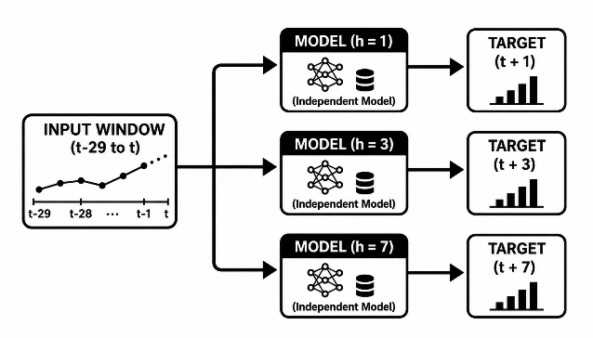
Figure 6. Direct Multi-Step Forecasting Strategy for 1-Day, 3-Day, and 7-Day Horizons

- Model Evaluation
The comparative performance of the standalone and hybrid models is evaluated using exclusively the out-of-sample testing data to ensure an unbiased representation of real-world predictive capability [8]. Before calculating the error metrics, all scaled model predictions and actual target values are inversely transformed back to their original Indonesian Rupiah (IDR) denominations to provide an economically meaningful assessment [13]. The evaluation relies on three standard regression metrics: Root Mean Squared Error (RMSE), Mean Absolute Error (MAE), and Mean Absolute Percentage Error (MAPE) [6], [4].
The Root Mean Squared Error (RMSE) measures the standard deviation of the prediction residuals, applying a heavier penalty to larger forecasting errors by squaring the deviations before averaging:
$$RMSE=\sqrt{\frac{1}{N}\sum_{i=1}^{N}{{\left(y_{i}-{\overset{ˆ}{y}}_{i}\right)}^{2}}}$$ | (2)
The Mean Absolute Error (MAE) provides a linear perspective of the model's accuracy by calculating the average of the absolute differences between the predicted and actual prices:
$$MAE=\frac{1}{N}\sum_{i=1}^{N}{|}y_{i}-{\overset{ˆ}{y}}_{i}|$$ | (3)
The Mean Absolute Percentage Error (MAPE) normalizes the absolute errors by the actual values, presenting the average error magnitude as a percentage. This allows for a scale-independent evaluation of the model's performance across different horizons:
$$MAPE=\frac{100\%}{N}\sum_{i=1}^{N}{\left|\frac{y_{i}-{\overset{ˆ}{y}}_{i}}{y_{i}}\right|}$$ | (4)
In these equations, $y_{i}$ represents the In these equations, $y_{i}$ represents the actual Bitcoin close price, ${\overset{ˆ}{y}}_{i}$ denotes the forecasted price, and $N$ indicates the total number of samples within the testing dataset [4]. The comprehensive application of these three metrics provides a holistic view of the models' sensitivity to outliers, average precision, and relative error consistency across the varying multi-step forecasting horizons [6], [9].

- RESULTS AND DISCUSSION

- Experimental Result Overview
The predictive performance of the standalone Long Short-Term Memory (LSTM) network, the standalone eXtreme Gradient Boosting (XGBoost) algorithm, and the sequential Hybrid LSTM-XGBoost stacking architecture was rigorously evaluated using a chronological out-of-sample testing framework. The testing dataset comprised historical Bitcoin to Indonesian Rupiah (BTC/IDR) market data from January 1, 2026, to May 20, 2026, ensuring that the models were assessed on entirely unseen future data [7], [2]. To prevent the exponential accumulation of forecasting errors typically associated with traditional recursive methodologies, a Direct Multi-Step (DMS) forecasting strategy was implemented to project prices independently across 1-day, 3-day, and 7-day horizons [18], [16]. The experimental evaluation was quantitatively driven by three standard regression metrics: Root Mean Squared Error (RMSE) to measure the models' sensitivity to significant forecasting outliers, Mean Absolute Error (MAE) to provide a linear perspective of the average absolute monetary deviation, and Mean Absolute Percentage Error (MAPE) to offer a scale-independent percentage of accuracy critical for assessing highly volatile cryptocurrency assets [6], [4].

Table 3. Overall Forecasting Performance of LSTM, XGBoost, and Hybrid LSTM–XGBoost
Algorithm Model | Horizon (Days) | RMSE (IDR) | MAE (IDR) | MAPE (%)
XGBoost | 1 | 69,907,347.45 | 47,396,747.95 | 3.894
XGBoost | 3 | 85,145,091.48 | 64,784,713.23 | 5.226
XGBoost | 7 | 121,486,314.10 | 95,414,687.71 | 7.661
LSTM | 1 | 62,927,542.68 | 46,816,226.67 | 3.642
LSTM | 3 | 83,551,933.44 | 64,338,270.84 | 4.994
LSTM | 7 | 116,982,086.30 | 84,757,549.16 | 6.765
Hybrid Model | 1 | 69,364,214.83 | 52,384,889.26 | 4.117
Hybrid Model | 3 | 73,769,422.33 | 53,715,736.87 | 4.231
Hybrid Model | 7 | 114,341,538.60 | 86,613,755.80 | 6.900

- Results of 1-Day Forecasting
For the immediate 1-day forecasting horizon, the experimental results demonstrated that the standalone LSTM network achieved superior predictive accuracy compared to the other architectures. The LSTM model recorded the lowest errors across all evaluated metrics, yielding an RMSE of 62,927,542 IDR, an MAE of 46,816,226 IDR, and a MAPE of 3.642% [13]. In comparison, the standalone XGBoost model generated higher error margins, with an RMSE of 69,907,347 IDR, an MAE of 47,396,747 IDR, and a MAPE of 3.894%. Interestingly, the Hybrid LSTM-XGBoost model also underperformed the standalone LSTM in this specific timeframe, recording an RMSE of 69,364,214 IDR, an MAE of 52,384,889 IDR, and a MAPE of 4.117%. These results indicate that for ultra-short-term forecasting, the sequential memory and gating mechanisms of the LSTM are exceptionally proficient at mapping immediate market momentum based on the 30-day lookback window [13], [12]. The result suggests that the residual correction mechanism did not provide an additional predictive advantage at the 1-day horizon under the experimental configuration. The XGBoost meta-learner, in attempting to minimize an already minuscule in-sample residual error, may have overfitted the minor noise fluctuations present in the 1-day step training data, resulting in the observed out-of-sample performance deterioration [5], [15].

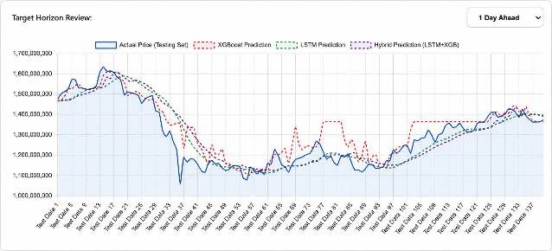
Figure 7. Comparison of Actual and Predicted BTC/IDR Prices for the 1-Day Forecasting Horizon
- Results of 3-Day Forecasting
As the prediction horizon extends to 3 days, the forecasting difficulty inherently increases due to the accumulation of unpredictable market volatility and the diminishing relevance of immediate historical data patterns [8], [11]. Under this medium-term scenario, the proposed Hybrid LSTM-XGBoost stacking architecture demonstrated its operational strength, comprehensively outperforming both standalone baselines. The Hybrid model achieved the lowest error metrics across the board: an RMSE of 73,769,422 IDR, an MAE of 53,715,736 IDR, and a MAPE of 4.231%. In contrast, the standalone LSTM saw a significant increase in errors, recording an RMSE of 83,551,933 IDR, an MAE of 64,338,270 IDR, and a MAPE of 4.994%. The standalone XGBoost model exhibited the weakest performance, with an RMSE of 85,145,091 IDR, an MAE of 64,784,713 IDR, and a MAPE of 5.226%. The result indicates that the residual-correction mechanism provided an additional predictive benefit at the 3-day horizon under the evaluated configuration. The XGBoost meta-learner demonstrates its capability to isolate and model the non-linear residual errors generated by the LSTM base learner, significantly refining the final prediction and proving the efficacy of the sequential stacking mechanism for medium-term horizons [10], [7].

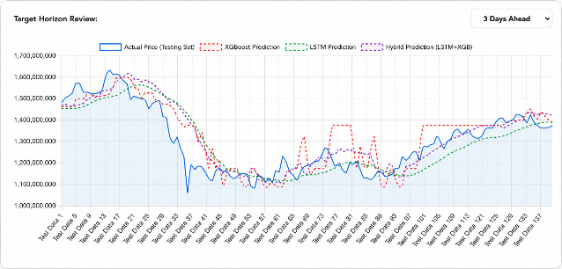
Figure 8. Comparison of Actual and Predicted BTC/IDR Prices for the 3-Day Forecasting Horizon
- Results of 7-Day Forecasting
For the 7-day forecasting horizon, the predictive accuracy of all evaluated models degraded significantly, vividly reflecting the chaotic, non-stationary nature of cryptocurrency markets over extended timeframes [1], [3]. The evaluation results at this horizon reveal a nuanced split in performance superiority between the LSTM and the Hybrid models. The Hybrid model achieved the lowest RMSE of 114,341,538 IDR, outperforming the LSTM (116,982,086 IDR) and XGBoost (121,486,314 IDR). Because the RMSE metric squares prediction errors before averaging, the lower RMSE indicates that the Hybrid model produced a lower squared-error magnitude on the testing observations [4], [6]. This result suggests that the Hybrid model may provide an advantage in reducing larger prediction errors under the evaluated 7-day forecasting setting. Conversely, the standalone LSTM retained the lowest MAE (84,757,549 IDR) and MAPE (6.765%), compared to the Hybrid model's MAE of 86,613,755 IDR and MAPE of 6.899%. This distinction indicates that while the Hybrid model provides better protection against extreme tail-end forecasting errors, the standalone LSTM maintains a slightly superior average prediction consistency over the long-term sequence [2], [13]. The standalone XGBoost remained the least accurate model, producing an MAE of 95,414,687 IDR and a MAPE of 7.661%.

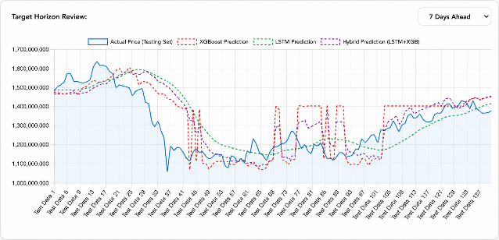
Figure 9. Comparison of Actual and Predicted BTC/IDR Prices for the 7-Day Forecasting Horizon

- Comparative Analysis Across Forecasting Horizons
A comprehensive comparative analysis across the 1-day, 3-day, and 7-day horizons elucidates the distinct behavioral characteristics and structural limitations of each predictive architecture. As the forecasting horizon increases, a universal degradation in predictive accuracy is observed across all models, validating that temporal distance exponentially increases market uncertainty [8]. Within the experimental configuration used in this study, standalone XGBoost generally produced higher prediction errors than the LSTM and Hybrid models across virtually all evaluated horizons. This persistent underperformance may highlight a methodological limitation: when three-dimensional sequential time-series data is flattened into two-dimensional arrays for tree-based ensemble learning, the inherent temporal granularity required to anticipate continuous sequential market shifts may be compromised [14], [15].
Conversely, the standalone LSTM network demonstrated exceptional robustness throughout the experiments. It proved superior for immediate short-term forecasting (1-day horizon) and maintained the best average long-term consistency, evidenced by capturing the lowest MAE and MAPE at the 7-day mark [9]. The proposed Hybrid LSTM-XGBoost stacking architecture excelled specifically in the medium-term (3-day) horizon, where it successfully isolated and corrected non-linear residual errors that the base LSTM learner failed to process [7]. Furthermore, its ability to secure the lowest RMSE at 7 days suggests its utility in mitigating larger predictive deviations [5]. The most prominent finding of this comparative analysis is that no single model consistently dominates across all forecasting horizons and evaluation metrics. These dynamics scientifically validate that integrating multiple models into a hybrid architecture does not automatically guarantee universal superiority across all timeframes [11]. Instead, the efficacy of the residual-correction stacking mechanism is highly context-dependent, relying heavily on the magnitude and structural nature of the errors generated at specific forecasting windows [18].

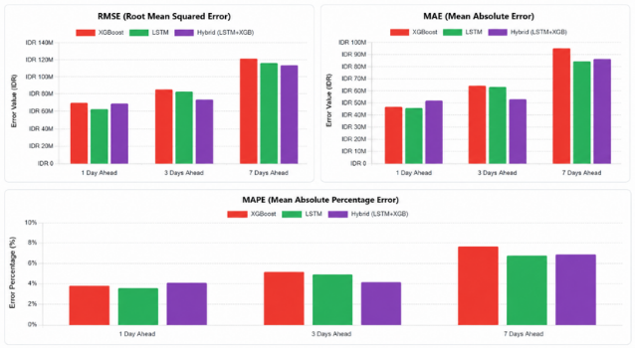
Figure 10. Comparative Model Performance Across Forecasting Horizons

- Discussion of Key Findings
The experimental outcomes of this study provide deep scientific insights into the intersection of computational intelligence and digital asset forecasting [17]. The volatility of Bitcoin necessitates predictive models capable of both adaptive learning and temporal preservation [10]. The LSTM network naturally mitigates the vanishing gradient problem through its specialized internal cell states, enabling it to accurately map continuous historical price patterns to imminent price discovery phases, which explains its dominance in the 1-day horizon [2], [13]. In contrast, while the standalone XGBoost struggles to process raw temporal sequences effectively, its deployment as a meta-learner within the Hybrid architecture maximizes its gradient-boosting strengths [14]. By isolating the target to merely predict the residual deviation from the LSTM baseline, the XGBoost layer effectively models these non-linear anomalies without requiring complex feature engineering, peaking in efficiency at the 3-day horizon [5], [15].
This research also corroborates previous studies indicating that the Direct Multi-Step (DMS) forecasting strategy was used to generate independent forecasts for each horizon, thereby avoiding the recursive propagation of previous predictions within the forecasting procedure [18], [16]. However, the experiment reveals a critical operational nuance regarding ensemble modeling: residual-correction stacking appears most potent when prediction errors are large enough to be modeled effectively by the meta-learner (3-day horizon) but not so large that they degrade the overall signal (7-day horizon) [8], [6]. Hyperparameter optimization for XGBoost was performed using RandomizedSearchCV with three-fold cross-validation. Although the final model evaluation was conducted chronologically on the held-out testing period, the cross-validation procedure used for hyperparameter selection does not explicitly enforce temporal ordering. Additionally, the residual-correction stage uses in-sample predictions from the LSTM base learner, which may introduce optimistic residual patterns and potential overfitting in the meta-learner. The increase in forecasting errors with longer horizons indicates that prediction becomes more difficult as the forecasting horizon extends under the evaluated dataset and model configuration. This pattern may be associated with the increasing uncertainty of longer-horizon price movements, although the present study does not explicitly isolate the contribution of external market factors such as regulatory announcements or macroeconomic sentiment [3], [1].
Therefore, for practical deployment in forecasting-based decision support and cryptocurrency market analysis, there is no single universally optimal algorithm [10]. Financial analysts and software engineers must dynamically select forecasting architectures based on the desired analysis horizon [11]. Standalone deep learning models like LSTM should be prioritized for immediate, short-term prediction strategies, whereas hybrid residual-correction architectures may be deployed for medium-term strategic planning to actively suppress predictive anomalies [17], [5].

- CONCLUSION

This study evaluated and compared the predictive performance of a standalone Long Short-Term Memory (LSTM) network, an eXtreme Gradient Boosting (XGBoost) algorithm, and a sequential Hybrid LSTM-XGBoost stacking framework for Bitcoin (BTC/IDR) price forecasting. Utilizing a Direct Multi-Step (DMS) forecasting strategy to avoid the recursive propagation of previous predictions, the models were assessed across 1-day, 3-day, and 7-day horizons using out-of-sample testing data. The empirical results indicate that model performance is highly horizon-dependent. For the immediate 1-day horizon, the standalone LSTM model achieved the highest accuracy, recording the lowest Root Mean Squared Error (RMSE), Mean Absolute Error (MAE), and Mean Absolute Percentage Error (MAPE). Conversely, as the forecasting window extended to 3 days, the proposed Hybrid LSTM-XGBoost model demonstrated its effectiveness by yielding the lowest errors across all three metrics. At the 7-day horizon, forecasting accuracy degraded across all models; however, the Hybrid model maintained the lowest RMSE, whereas the standalone LSTM retained the lowest MAE and MAPE. Within the evaluated experimental configuration, the standalone XGBoost generally produced higher forecasting errors compared to the deep learning and hybrid architectures.
The primary scientific contribution of this research lies in providing a systematic comparative evaluation demonstrating that no single predictive architecture universally dominates across all timeframes. The findings suggest that the sequential memory capability of the standalone LSTM is optimal for immediate, short-term predictions. The residual-correction mechanism of the Hybrid model, which utilizes XGBoost to model the errors generated by the LSTM base learner, provides an observable predictive advantage specifically in the medium-term (3-day) horizon and helps mitigate larger squared errors (RMSE) at the 7-day horizon. These insights may support the selection of forecasting models according to the intended prediction horizon in forecasting-based decision-support applications and cryptocurrency market analysis.
While the study offers valuable insights into cryptocurrency forecasting, several limitations should be noted. The models rely primarily on historical Open and Close prices and therefore do not explicitly incorporate external market variables, trading volume, or macroeconomic indicators. Methodologically, the residual-correction stage of the Hybrid model relies on in-sample predictions from the LSTM base learner, which may introduce potential overfitting in the meta-learning stage. Additionally, the hyperparameter optimization of the XGBoost models used conventional three-fold cross-validation rather than a strictly time-aware validation strategy. Future research could explore the integration of exogenous features, such as sentiment analysis or on-chain metrics, and investigate more robust temporal validation techniques to further enhance the reliability of multi-step cryptocurrency forecasting models.

BIBLIOGRAPHY

[1] L. T. Hoang, “Cryptocurrency price-based comovement,” International Review of Economics & Finance, vol. 104, p. 104635, Dec. 2025, doi: 10.1016/j.iref.2025.104635.
[2] B. Rachmadani, “Forecasting Bitcoin Price Using LSTM Networks Optimized with Adam Optimizer,” International Journal of Application Computer Science and Informatic Engineering), vol. 6, no. 1, pp. 37–48, 2024, doi: 10.33173/acsie.v6i1.299.
[3] D. Li, “The impact of expected and unexpected factors on the price of Bitcoin,” 2024, pp. 395–403. doi: 10.2991/978-94-6463-268-2_43.
[4] H. Alizadegan, A. Radmehr, and M. A. Ilani, “Forecasting Bitcoin Prices: A Comparative Study of Machine Learning and Deep Learning Algorithms,” May 09, 2024. doi: 10.21203/rs.3.rs-4390390/v1.
[5] A. Munazilin, M. A. Wibowo, and R. Parlika, “A Hybrid Ensemble Stacking Framework Integrating Long Short-Term Memory and Random Forest for Bitcoin Price Forecasting,” Journal of Information Systems and Informatics, vol. 8, no. 2, pp. 1891–1912, Apr. 2026, doi: 10.63158/journalisi.v8i2.1537.
[6] C. Özgür, “Deep Neural Networks in Predicting Financial Volatility: An Application on Cryptocurrencies,” Mehmet Akif Ersoy Üniversitesi İktisadi ve İdari Bilimler Fakültesi Dergisi, vol. 12, no. 2, pp. 542–558, Jun. 2025, doi: 10.30798/makuiibf.1530528.
[7] P. H. Vuong, L. H. Phu, T. H. Van Nguyen, L. N. Duy, P. T. Bao, and T. D. Trinh, “A bibliometric literature review of stock price forecasting: From statistical model to deep learning approach,” Sci. Prog., vol. 107, no. 1, Jan. 2024, doi: 10.1177/00368504241236557.
[8] S. U. Maitoro et al., “Forecasting Bitcoin Price Volatility: A Comparative Analysis of Fuzzy Time Series, ARIMA, and GARCH Models for Short-Term and Long-Term Predictions,” Journal of Advanced Research in Computing and Applications, vol. 41, pp. 144–153, 2025, doi: 10.37934/arca.41.1.144153.
[9] A. İ. Şimşek, “Predicting Bitcoin Price: Comparative Analysis of Machine Learning and Deep Learning Models,” Savunma Bilimleri Dergisi, Apr. 2024, doi: 10.17134/khosbd.1394501.
[10] R. Kumar Ray et al., “MULTI-MARKET FINANCIAL CRISIS PREDICTION: A MACHINE LEARNING APPROACH USING STOCK, BOND, AND FOREX DATA,” Int. J. Appl. Math. (Sofia)., vol. 38, no. 8s, 2025.
[11] S. O. Arik, N. C. Yoder, and T. Pfister, “Self-Adaptive Forecasting for Improved Deep Learning on Non-Stationary Time-Series,” Sep. 2022, [Online]. Available: http://arxiv.org/abs/2202.02403
[12] T. Perumal, N. Mustapha, R. Mohamed, and F. M. Shiri, “A Comprehensive Overview and Comparative Analysis on Deep Learning Models,” Journal on Artificial Intelligence, vol. 6, no. 1, pp. 301–360, 2024, doi: 10.32604/jai.2024.054314.
[13] H. Yao, “Research on Stock Price Prediction Based on Machine Learning Techniques,” in Proceedings of the 2nd International Conference on Data Science and Engineering, SCITEPRESS - Science and Technology Publications, 2025, pp. 654–659. doi: 10.5220/0013703600004670.
[14] A. Faqih and T. Sugihartono, “Perbandingan Algoritma XGBoost dan LSTM dalam Prediksi Harga Saham Tesla Menggunakan Data Tahun 2025,” Jurnal Pendidikan dan Teknologi Indonesia, vol. 5, no. 6, pp. 1563–1573, Jun. 2025, doi: 10.52436/1.jpti.836.
[15] M. Gautam, “crypto price prediction using lstm+xgboost,” Jun. 2025, [Online]. Available: http://arxiv.org/abs/2506.22055
[16] Q. Guo, S. Lei, Q. Ye, and Z. Fang, “MRC-LSTM: A Hybrid Approach of Multi-scale Residual CNN and LSTM to Predict Bitcoin Price,” May 2021, [Online]. Available: http://arxiv.org/abs/2105.00707
[17] E. Boadi, “Bitcoin Price Forecasting Based on Hybrid Variational Mode Decomposition and Long Short Term Memory Network,” Sep. 2025, [Online]. Available: http://arxiv.org/abs/2510.15900
[18] T. M. Łapiński and K. Ziółkowski, “Ensembled Direct Multi-Step forecasting methodology with comparison on macroeconomic and financial data,” Oct. 2025, [Online]. Available: http://arxiv.org/abs/2509.13945

